

Project Plan

Million Aboye

ITE 170 - 001N

September 11, 2022



**Purpose:**

My website's primary objective is to provide specific, useful information about NFT to my visitors/audience so that they can learn something new or better understand NFT's. My website is geared toward more actionable information and may include what an NFT is, how to obtain an NFT, tips to consider when purchasing an NFT, and NFT prices.

**Website Name:**

I'm considering naming my website "digital unicorn" because I'm working on a digital asset. This would be a descriptive name that gives people a clear idea of what the website is all about and emphasizes how NFT's are desirable, rare, and hard to find, much like a unicorn.

**similar or Competitor Websites.**

<https://www.cnn.com/2021/03/17/business/what-is-nft-meaning-fe-series/index.html>

CNN published an article on what an NFT is and how to obtain one in November 2021, but this article was insufficient for grasping knowledge and applying it in the eco system. One mistake I noticed in this article is that they did not provide a detailed step-by-step procedure for acquiring an NFT and the website is not visually appealing and they throw everything in one page which makes it less interactive with the audience but they did a great job explaining what an NFT is in a clear way to their audience.

**Demographics:**

I hope that anyone who is fascinated by technology, digital ecosystems, and financial literacy will visit my website, but to narrow the gap, I believe that young people in the technology field will be interested and will visit my website.

**Pages:**

1. What is an NFT (landing page)

* The landing page include a detailed explanation of NFT, history, fun facts, and pictures.

1. Tips

* This page will include tips and tricks on how to identify a good NFT in the market.

1. Mint

* Mint is a common term in NFT community which refers purchasing an NFT. This page will include every procedure to purchase an NFT.

1. Prices

* I will discuss pricing of different NFT’s in a different marketplace.

1. Contact

* I haven’t decided what to include on this page or not to have this page at all because I’m thinking to put the contact information in each page in the footer, but we will find out when we go through the project.

**Wireframe Layouts:**

* This is the **Landing page** with a navigation bar in the top right header, a paragraph explaining what an NFT is and picture on the side and a footer at the bottom including a navigation and social media bar.

* This is the **Tips page** where I will provide considerations while purchasing an NFT. The header and footer will be the same as the landing page but quite different in the main screen area there will a parallel faced text and picture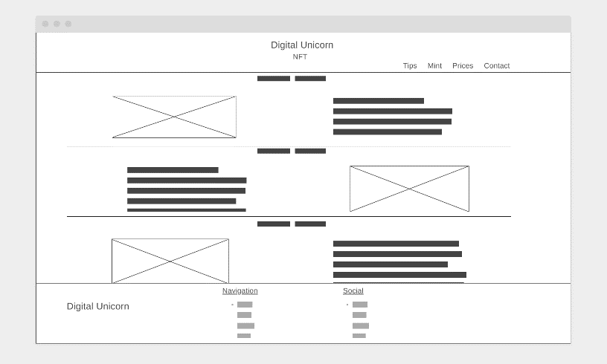
* **Mint page** on this page there would be step by step direction with a picture or video under it.

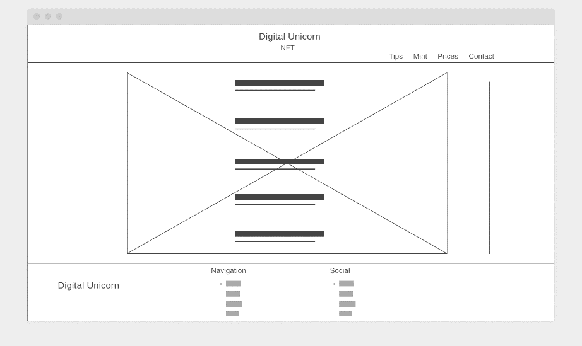

* **Price page** this page will include the most valuable NFTs in the marketplace with their price tag under it and few sentence explanation of NFT prices.

* **Contact page** with a bar to provide Full name, email and the feed back